Outsiders Leasing the Land?
The Elliot Lease of 1920
Pima-Maricopa Irrigation Project Education Initiative
2002-2003

Restoring water to ensure the
continuity of the Akimel O’otham
and Pee Posh tradition of agriculture

Re

The Pimas had boasted in 1916 that none of their land (outside a government agricultural experiment station in Sacaton) had been leased to non-Indians. Allotment was not yet completed when the first secret plans were drawn up for the leasing of a large portion of the reservation. Still fighting to restore their rightful share of river water, the Pimas prepared to defend their land once again.
Part 26

When the last allotment was made at Gila River, more than 96,000 acres of land had been divided between 4,894 Pimas and Maricopas. Within five years, fifteen percent of the allottees had died and within seven years, one in four had passed away. Almost all of this allotted land was considered “susceptible of irrigation,” although only the A allotments were to be provided with water. An additional 10,422 acres of tribal land was also considered irrigable. Of the 4,894 allotments, just 1,654 were “under ditch” by 1922. The largest Pima farmers were Jose Mendoza (100 acres), Jack Stone (96 acres), Lewis Porter (60 acres), Frank Armstrong (55 acres), Pancho Lopez (54 acres), Joseph Smith (52 acres), John Jones (50 acres), Jose Kalka (50 acres) and Ed Wood (50 acres). Many others were farming between 30-50 acres. Typical crops included wheat, barley, alfalfa, corn, cotton, beans, squash and a variety of garden crops.
Nearly half of the irrigable allotments for which ditches and turnouts were constructed turned out to be “unfit for the purpose for which [they] had been allotted.” Soil analyses showed half of the 50,000 irrigable acres allotted contained “excessive amounts of alkali” and were condemned. Superintendent Albert Kneale later wrote that allotment and the canal system built to serve allottees were “idle gestures because they all proved futile and the [Bureau of Indian Affairs] must have known in advance that neither singly or collectively could they have any effect upon the water situation or upon the financial status of the tribe.” Excessive alkalinity meant a second survey to locate an additional 25,000 in-lieu acres of irrigable land was necessary so allottees that had lost some or all of their original irrigable allotment could receive a different one.
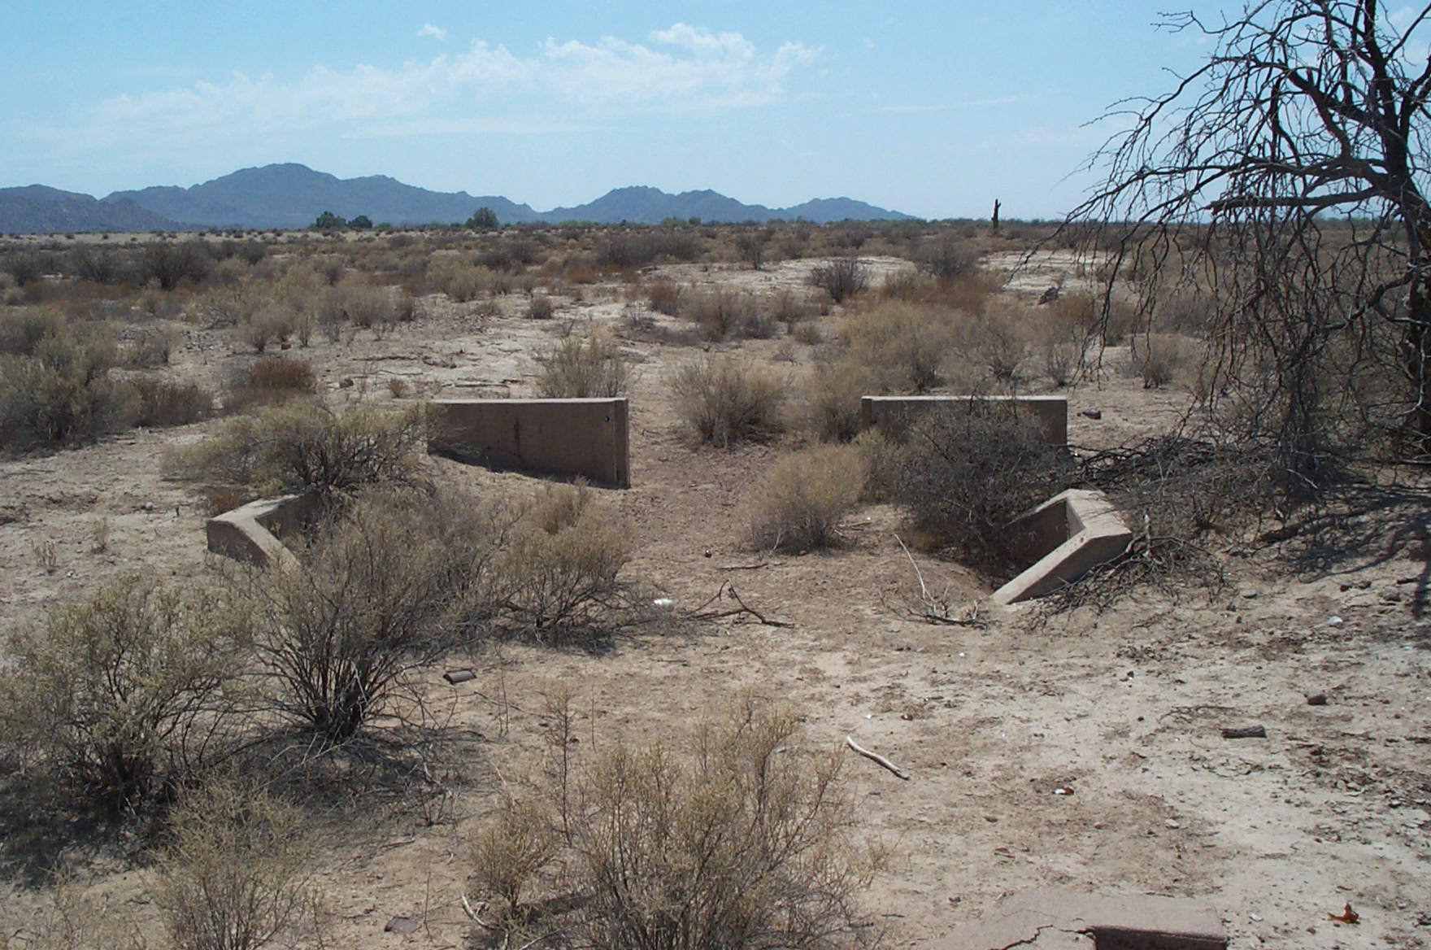
Some allottees received two separate 10-acre allotments within an area designated as irrigable (with canal service), while some received two allotments, both of which were outside the service area. In some cases, Pimas received an allotment in an area that was later condemned due to alkalinity. Since every member was entitled to 10 acres of irrigable land, the only solution offered by the Indian Office was to “effect exchanges of allotments between individuals,” something that was accomplished with “an immense amount of labor.” With the exchanges came another expense: “the enlargement and revamping of the entire irrigation system.” One of the visual effects remains today: dozens of old canal structures abandoned in the desert in the eastern part of the reservation.
Allotment was far from successful. Rather than follow existing land divisions and local land customs, allotting agents laid new subdivision lines following the township structure. Rarely did an allotment correspond with the old system of fields and canals. Areas that had been farmed with river water for centuries, such as Sacate and Snaketown, were without water as new canals and irrigation systems were built. Families living in these traditional farming areas had little choice but to “go from place to place” looking for work. Nearly 7,000 acres of cleared allotted land was without water—and a crop—in 1922. In the Snaketown district, over 100 families abandoned their traditional farms and found work cutting wood or working for wages to meet their needs. By the mid-twenties, the amount of land actually in production decreased by 2,600 acres, much to the discouragement of the Pimas. Even a 1928 Government study found that allotment “led to a very patchy system of irrigation” and had resulted “in a large part of the land lying idle [or] poorly farmed.”
Despite hardships and insufficient water, 575 Pimas and Maricopas farmed 11,860 acres using pump, flood and seepage water by 1925. Because of drought conditions and new canals bypassing old fields, some Pima farmers in Sweetwater, Bapchule, Casa Blanca, Sacate and Snaketown “were unable to farm their land.” In Casa Blanca, 2,571 acres were planted but no crop grew due to insufficient water. While farmers in the Santan area managed to plant a crop, their grain yield was less than prior years. In Santa Cruz, 1,500 acres of productive land was divided into 75 twenty-acre farms, but lack of water prevented its development, much to the discouragement of the Pimas. Plans for a 1,500-acre farm in Co-op and a 2,500-acre farm in Maricopa Colony were initiated, as well.
Allotment—aided by water loss—disrupted the existing land division and traditional land usage. Many Pimas and Maricopas had opposed allotment, recognizing they would be unable to till the land using the modern machines necessary to compete with their non-Indian neighbors. The Indian Office—under Congressional mandate to repay the costs of the new irrigation system—demanded modernization but provided little or no financial support. Some allottees prophetically saw the day when “outsiders would one day farm [the] land because of our [lack of] financial resources.”
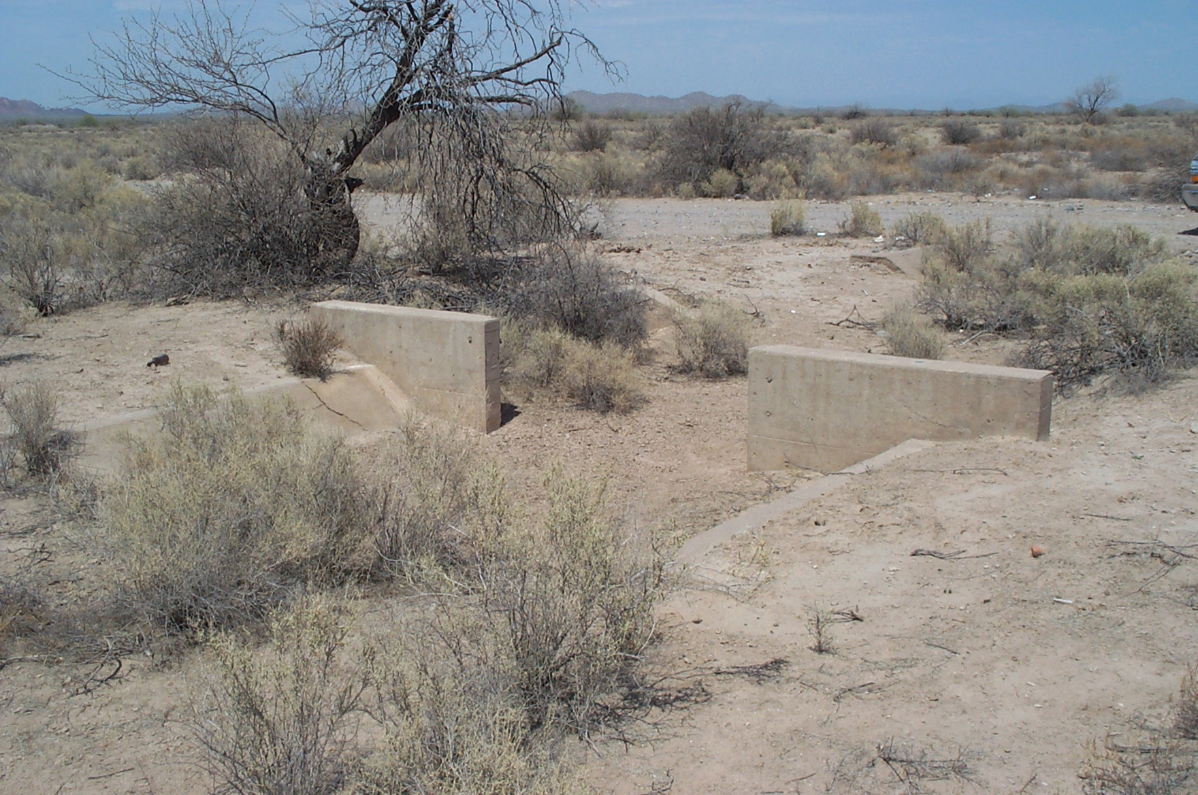
With allotment in place, the economic structure of the Pima and Maricopa changed. By 1918, the United States Government signed an eight-year lease on 250 ten-acre tracts of land (2,500 acres), with the land being irrigated with tail water from off the reservation. After eight years, the land—with improvements—would revert back to Pima control “in suitable condition for irrigation in raising of alfalfa.”
It was the 1918 Elliot Lease, however, that demonstrated how rapidly the Pima economy was changing. This lease was for 50,000 acres of allotted land made by the BIA with W.R. Elliot of Phoenix. It was made “without the [Pima’s] consent” and dated back to December 1918. While set up as a ten-year lease, the contract included a provision that allowed the lease to be extended indefinitely without the consent of the Pima landowners. The Agency superintendent was given authority to sign the lease “on behalf of minors and undetermined heirs, and such other Indians as may not be prepared to develop their land efficiently for agricultural purposes and who fail[ed] or refuse[d] to execute leases covering such land.” The Pimas were not informed of the lease until January 1920, after the Indian Office and the Secretary of the Interior had approved of it. The Pimas immediately protested the lease and once again engaged the assistance of the Indian Rights Association.
The Pima landowners were to receive 12.5 cents rent per acre for 10 years. This was to be payable at the end of the lease. According to the contract, the Pimas could receive the equivalent of $12.50 for each 10-acre allotment or one-fourth of each tract of land (2.5 acres) could be seeded to alfalfa. No payment was to be given until after the end of the lease. Leveling and installing ditches were the responsibility of Elliot. Such improvements (including electric wells) would belong to the allottees at the end of the lease, assuming Elliot did not unilaterally renew it. The benefit to the Pima, according the Indian Office, was that land then worth $10 an acre would be worth $300. These projections assumed a continued right to the use of water after the expiration of the lease. Such projects also indicated the desired economy of the reservation as defined by the Indian Office. Commissioner of Indian Affairs Cato Sells believed the value of the land would exceed $15,000,000 after the expiration of the lease.
In March of 1920, the Indian Rights Association contacted the House Committee on Indian Affairs. Representative M. Clyde Kelley was then persuaded to introduce into the House a resolution authorizing an investigation of the lease. The Indian Rights Association pointed out that the land could not be leased without the consent of the Pimas.
Even more remarkable is that the Pimas had irrigation rights to 35,000 acres of land and yet had water for no more than 12,000 acres at the time. This left 23,000 acres of eligible Pima land that could be developed for farming but was without water. Add to this the 50,000 acre Elliot Lease and there was an irrigation need for 73,000 acres. The Indian Rights Association was adamant that “before a drop of water is taken from the Gila River basin to irrigate the 50,000 acres proposed to be leased,” the 23,000 allotted Pima acres had to “be fully supplied.” If Elliot considered pumping groundwater from beneath the reservation (as he indicated he would) it would have had a direct effect on the reservation water resources and “lower[ed] the level of underground water.” By so doing, there would have been a corresponding diminished “surface flow in the River.”
The risks to the Pimas were many. Not only was their voice not heard in any of the lease discussions, it was not present, as all negotiations were done in secret. Bids for the land were not solicited and there were no advertisements. When the lease was made public, there were several interested parties in bidding on it—and at a greatly increased rental rate. The Pimas, who had difficulty securing water for 35,000 acres of their own land, had no assurance they would have access to whatever water was used on the land after the lease was expired. Owing to the mounting Pima and public outcry, Interior Secretary John Barton Payne canceled the lease in January 1921. Despite a near calamitous event, the Pimas learned an important lesson. They had to “make the best use possible of their lands by increasing the acreage under cultivation so as to rob the land grabbers of their excuse to rob.”
The Pimas were strongly opposed to leasing their land for fear that they would become dependent in their own homeland. They did not want the United States Government collecting lease moneys and paying them “pittances at stated intervals.” They did not wish to abandon “habits of thrift” nor did they wish to drift into “indolence and crime” because of the loss of their means to farm. The Elliot Lease unified the Pimas in their opposition to leasing their lands. But powerful forces were at work. The Indian Office expected the land to be farmed. Lack of financial resources, insufficient water, frustration at the long wait for restoring their water and entrance into the wage economy changed Pima agriculture. The Pimas needed a dependable source and supply of water if they were to remain self-sufficient.

Teacher Plan for “Outsiders Leasing the Land? The Elliot Lease of 1920”

Objectives

Students will be able to:

- Apply lessons learned from the Elliot Lease to the modern proposed water settlement of the Community.

- Analyze the effects of allotment on both individual Community members and the Community as a whole.
Terms to know and understand

- Calamitous
- Covert
- Lease
- Irrigable
- In-lieu

Critical Thinking:

- The Indian Rights Association stated in 1922 that the Pimas had learned an important lesson with the Elliot Lease. What do you think was meant by the statement “The Pimas must make the best use possible of their lands by increasing the acreage under cultivation so as to rob the land grabbers of their excuse to rob?” How might this statement be used today in terms of the Gila River Indian Community’s proposed water settlement? Why is it so important that you be involved in decisions that impact the Community and its future?

Activities:

- Invite a P-MIP speaker to your class to discuss soil analyses and classification. Why types of soil are there and what classifications exist. Inquire about why the soil is classified and certified.

- Have students research some of the traditional farming areas of the Community. Map them and determine why these areas are no longer farmed. What impact—if any—did the new irrigation system have on these traditional agricultural lands? In what ways did farming change in the Community?

- Take a field trip to the eastern portion of the reservation and locate the old abandoned irrigation check structures and canals. At the same time, look for evidence of old irrigation ditches. What do these ditches and structures tell you about the land?
About P-MIP

The Pima-Maricopa Irrigation Project is authorized by the Gila River Indian Community to construct all irrigation systems for the Community. When fully completed, P-MIP will provide irrigation for up to 146,330 acres of farmland. P-MIP is dedicated to three long-range goals:
- Restoring water to the Akimel O’otham and Pee Posh.
- Putting Akimel O’otham and Pee Posh rights to the use of water to beneficial use.
- Demonstrating and exercising sound management to ensure continuity of the Community’s traditional economy of agriculture.

